Project Development Phase
Model Performance Test
Date | 10 February 2025
Team ID | 6ab6292ddcdae33acb3906da
Project Name | Importing & Securing Data in ServiceNow (Import Data using Transform Maps)
Maximum Marks
Model Performance Testing:
Project team shall fill the following information in model performance testing template.
S.No. | Parameter | Screenshot / Values
1. | Data Rendered | Imported training data is shown in the Employee Training Records list (Completion Date, Employee, Status, Training Name).  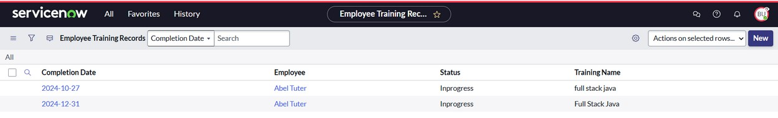
2. | Data Preprocessing | The spreadsheet columns were mapped to the target table using the Employee Transform: u_completion_date, u_status, u_training_name and u_employee_email to u_employee.  Import result: processed 4, inserts 3, errors 0, empty and ignored 1.  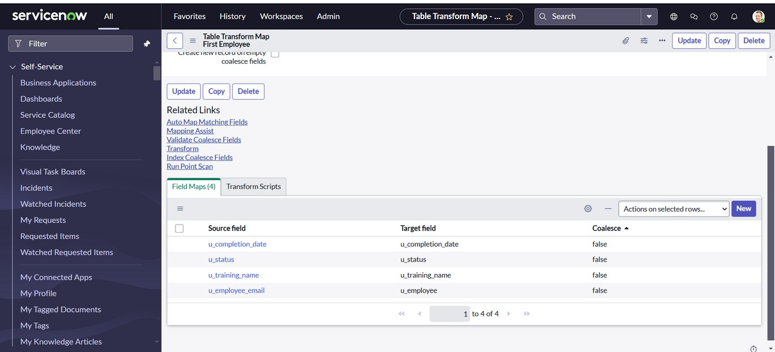
3. | Utilization of Data Filters | Not applicable: this project does not use Power BI filters. Records are viewed in the ServiceNow list view, which has a Completion Date search field.
4. | DAX Queries Used | Not applicable: no DAX queries were used. Employee department is pulled into each record by dot-walking (Employee.Department) instead.
5. | Dashboard design | No of Visualizations / Graphs - 0 (not applicable; the data is presented in a ServiceNow list view).
6. | Report design | No of Visualizations / Graphs - 0 (not applicable).

